Job Description

Position: Technical Services Assistant

Range: T4 (Non-Exempt) (Union)
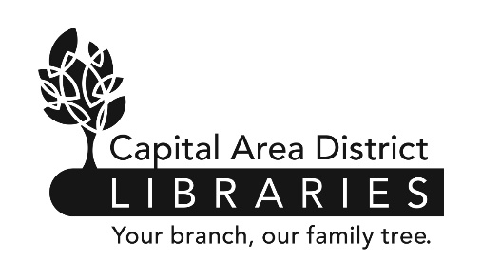
Reports to: Technical Services Supervisor

Supervises: None

Reviewed: 7/20 Revised: 7/20

Capital Area District Library
www.cadl.org

Job Summary

Under the supervision of the Technical Services Supervisor, the Technical Services Assistant ensures that incoming materials are matched to bibliographic catalog records, that these records are accurate and complete, and that they use consistent (authorized) names and subjects. Furthermore, the TS Assistant will help maintain the existing database noting and correcting errors, loading pre-prepared vendor records, and assisting in other maintenance projects. Finally, the TS Assistant will, as necessary, prepare cataloged materials for use in CADL branches, order new library materials, and verify received items against outstanding orders.

Duties and Responsibilities

- Matches incoming materials to an appropriate MARC catalog record, either pre-loaded from a vendor or downloaded from a bibliographic database (SkyRiver).

- Reviews newly matched bibliographic records for accuracy in accordance with Capital Area District Libraries’ current AACR2/RDA hybrid cataloging practices. Adds contents description, summary, and appropriate subject headings when this information is partial or missing. Ensures that pieces of multipart works appear consistently in the library’s catalog.

- Conducts authority work using SkyRiver and/or Library of Congress Authorities databases. Ensures the names, corporate bodies, subjects, and series titles used in each bibliographic record match the authorized version established by the Library of Congress. Adds new instances of a name, subject, or title to CADL’s local authority file.

- Assigns Dewey Decimal Call numbers to new records in accordance with DDC schema and local practices.

- Corrects errors in existing bibliographic records and combines duplicate records as needed.

- Assists in downloading and applying global updates to bibliographic records from various vendors, including Baker & Taylor and Midwest Tape. Downloads, corrects, and supplements records provided electronic content providers including Overdrive, Hoopla, Kanopy, and others.

- Responds to catalog requests and questions received from library staff. Maintains statistical information.

- Assists in catalog maintenance projects.

- Provides simple original cataloging under the supervision of the Technical Services Supervisor.

Technical Assistant Job Description
Page 1 of 2

- Aids other Technical Services departments, as necessary, by physically preparing items for circulation at branches, adding items to our integrated library software, ordering new materials requested by selection staff, and checking incoming materials and invoices against outstanding orders.

- Performs other duties as assigned, including assisting other departments or branches.

The above statements are intended to describe the general nature and level of work being performed by people assigned this classification. They are not to be construed as an exhaustive list of all job duties performed by personnel so classified.

Job Requirements

- Possession of a bachelor’s degree or its equivalent.

- This is an entry-level classification. No specific prior experience is required. Experience working in a public library is preferred.

- Experience using Sierra, SkyRiver or other automated cataloging system highly desirable.

- Experience or knowledge of libraries and library cataloging highly desirable.

- Successful completion of a six-month probationary period.

- Be physically able to perform the essential functions of the position, with or without reasonable accommodation.

- Ability to use computers and to utilize computer databases.

- Effective written and oral communication skills.

- Ability to establish and maintain effective working relationships with co-workers.

- Ability to conduct oneself with tact and courtesy.

Technical Assistant Job Description

