A library a place with lots of things to read and do
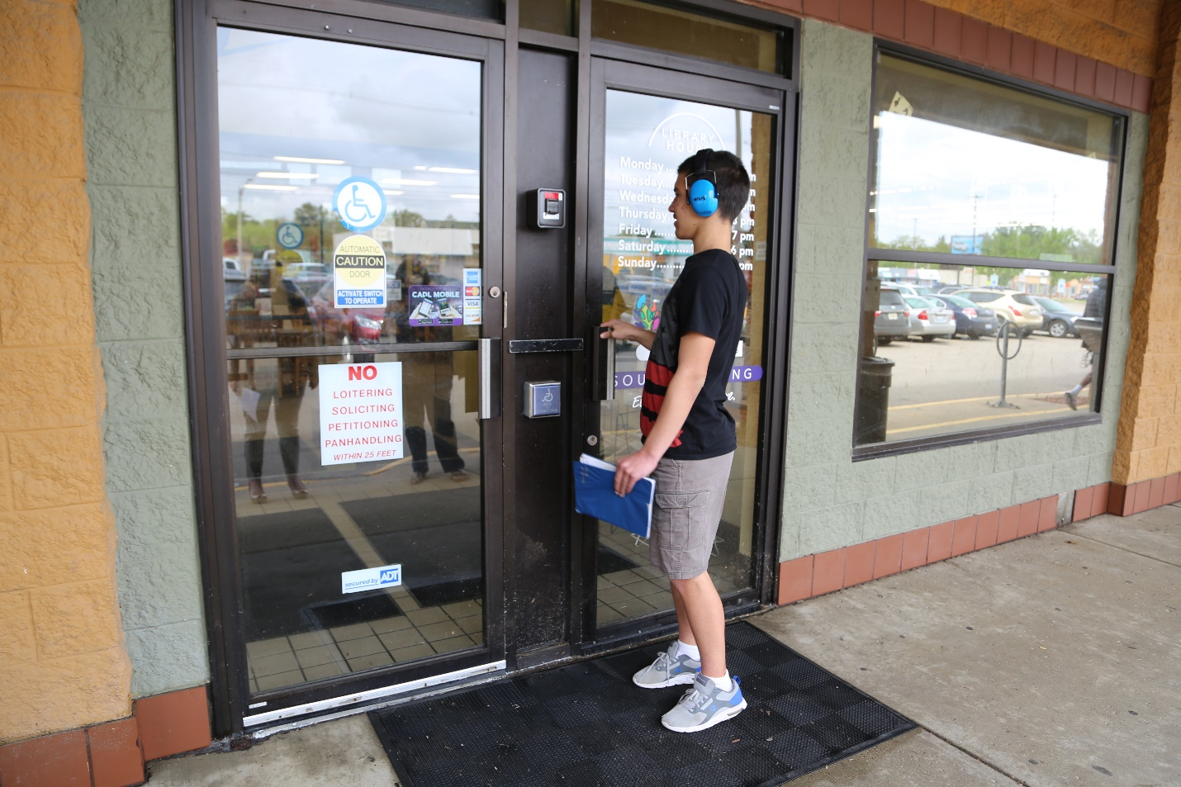
We will be there until: (Add clocks here)
If I have been to the library before, I may have items I need to bring back. If I have items to bring back to the library I can put these in the return slot.
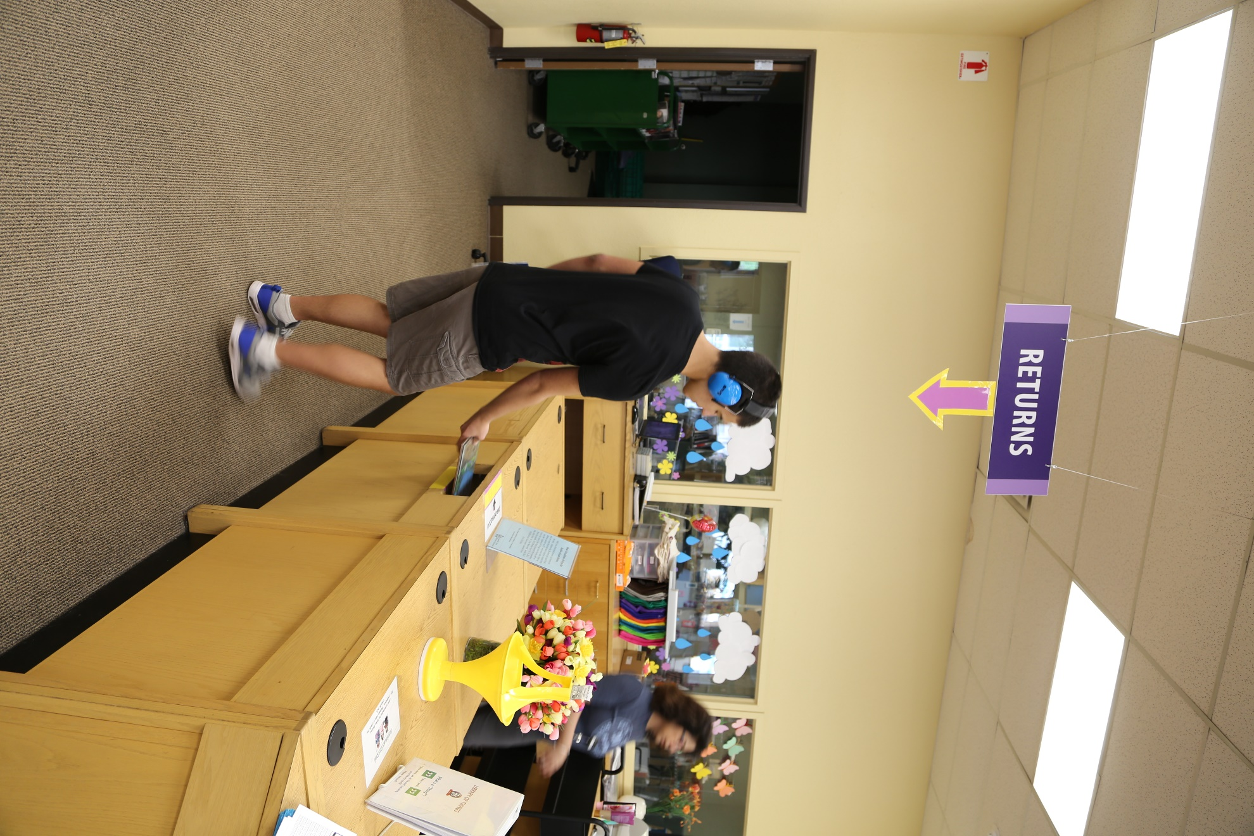
When I am in the library, I will always walk and not run.
I need a library card if I want to borrow items from the library and take them home.
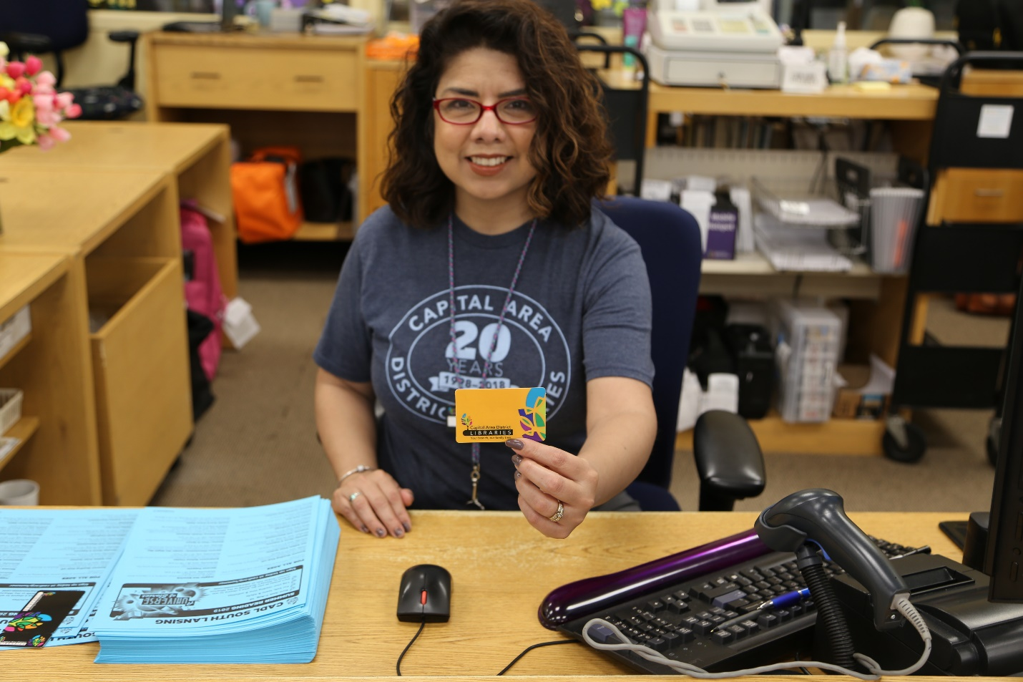
If I want to get a library card, first I need to fill out an application. My parents or caregiver can help.
When I get my library card, I can use it to check out items from the library.
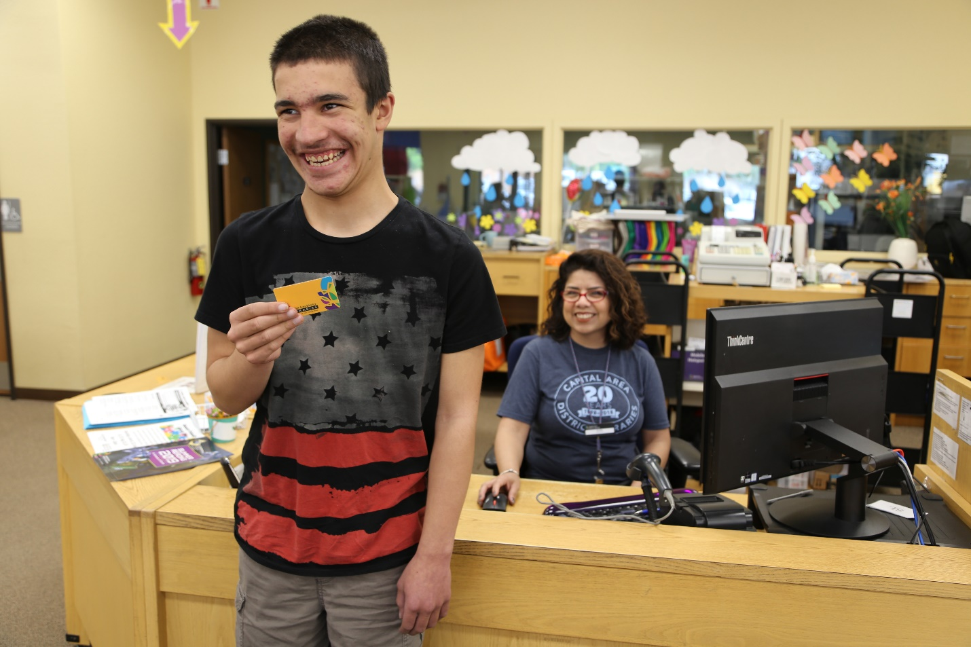
Books, audiobooks, magazines, comics, music and movies for kids are in the Children’s Area.
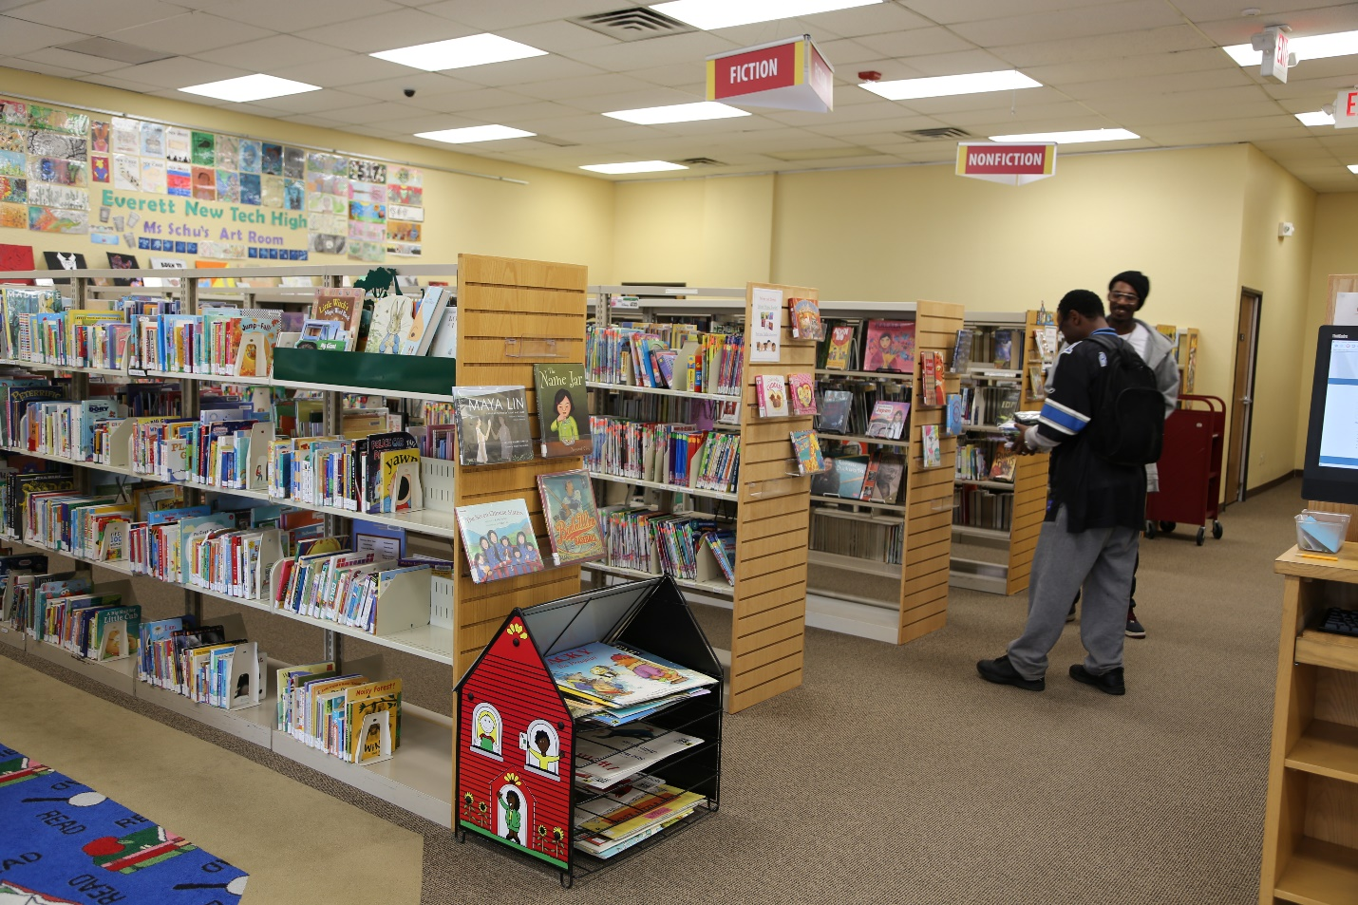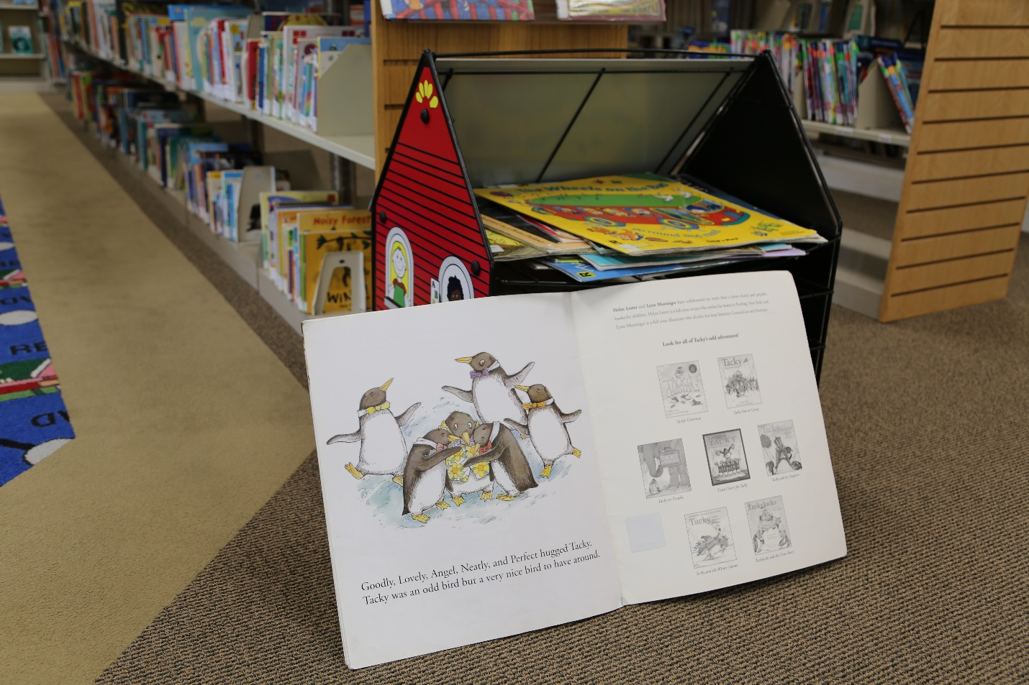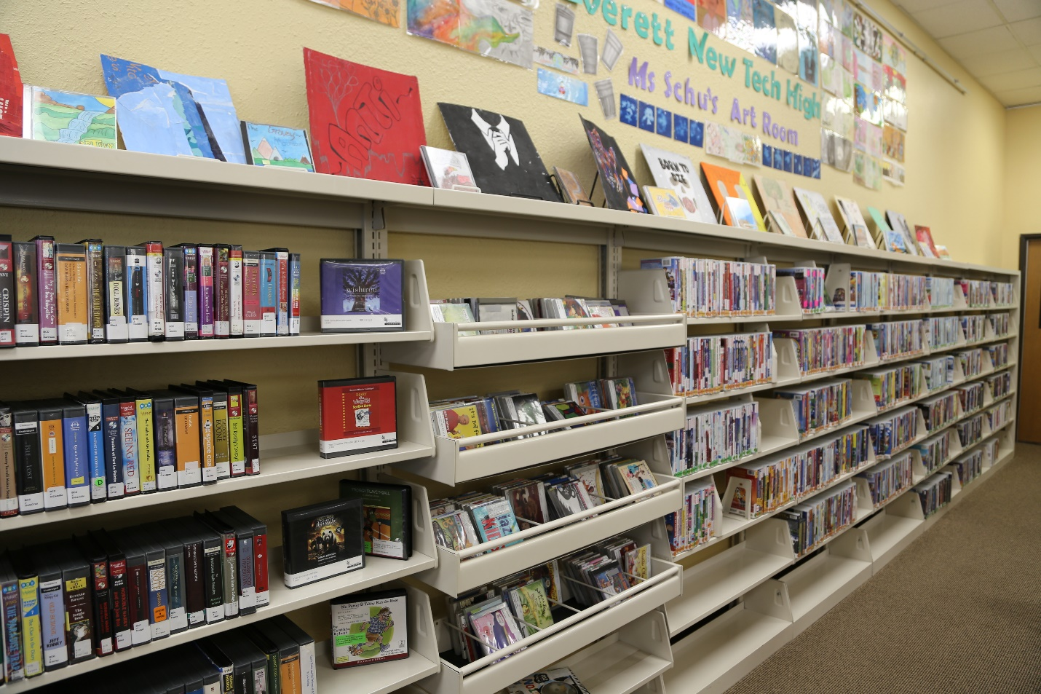
We have lots of picture books. Picture books have lots of pictures and short stories.
I can read books at the library, or I can borrow them and take them home.
(Insert open picture book here)
Beginning reader books are helpful for people who are beginning to learn how to read.
(Insert beginning reader section)
Some beginning reader books have just a few words on each page, and some have more.)
(Insert picture of open beginning readers)
I can look at different books to see which ones I would like to read.
There are chapter books with longer stories.
(picture of chapter book section)
There are stories about many different things.
(insert open chapter book)
There are books and comics for teens too.

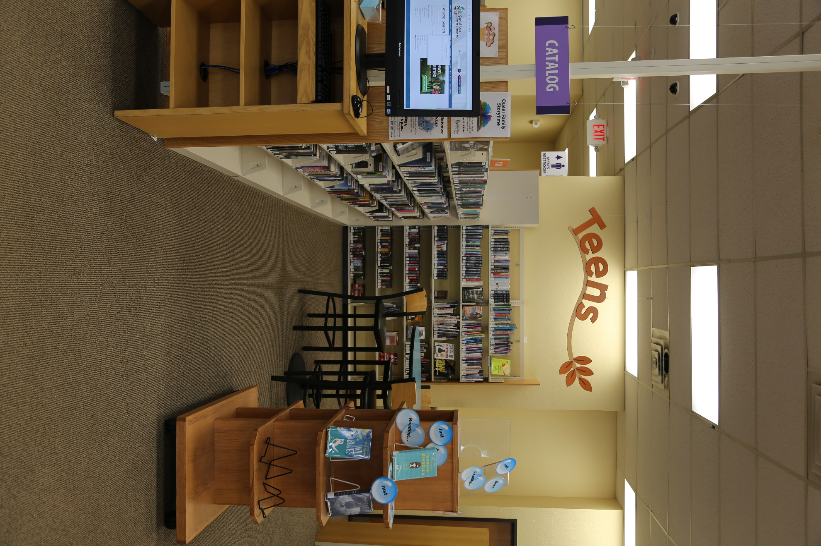
There are places in the library I can sit and read my books.
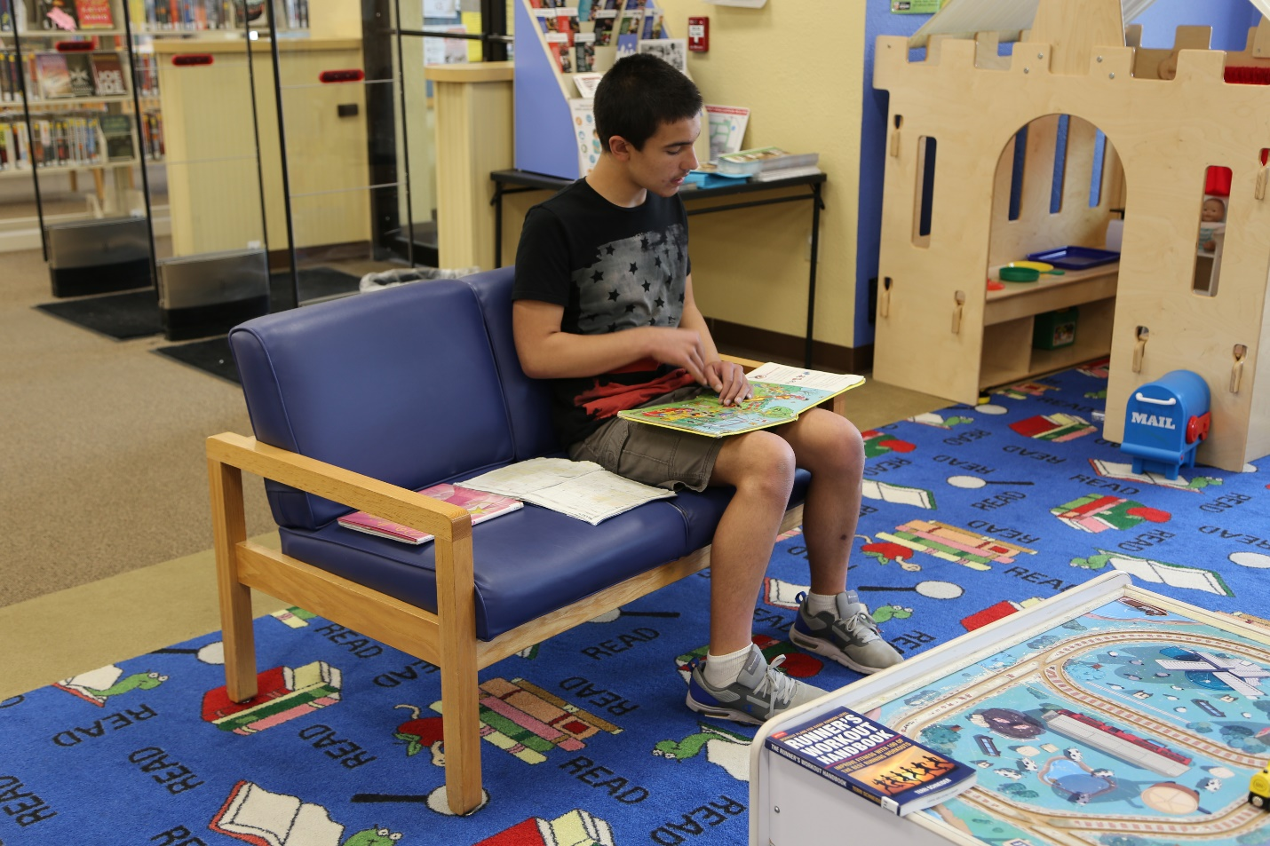
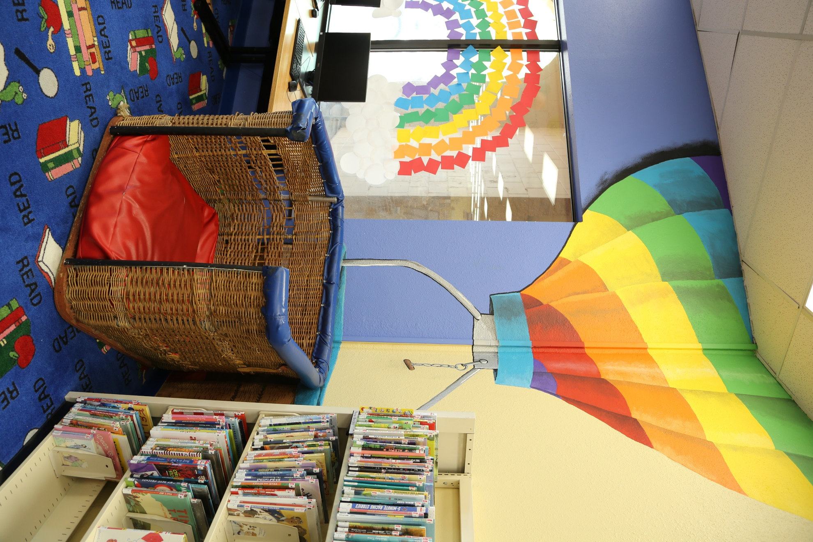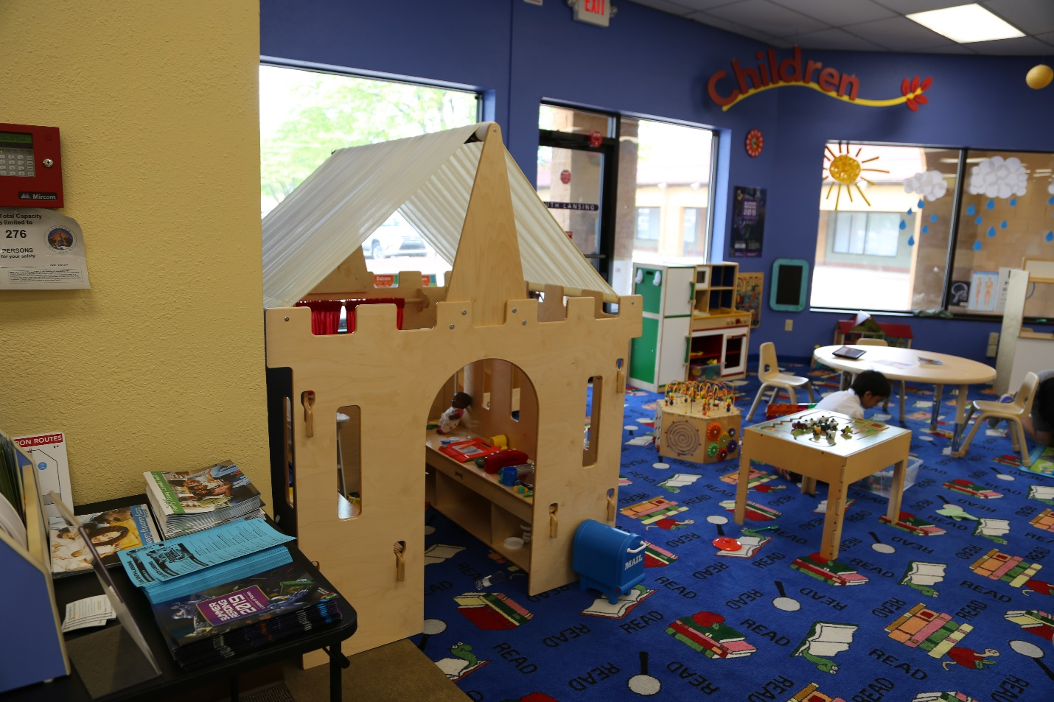

Other kids might be sitting at the tables and chairs too. I can share.
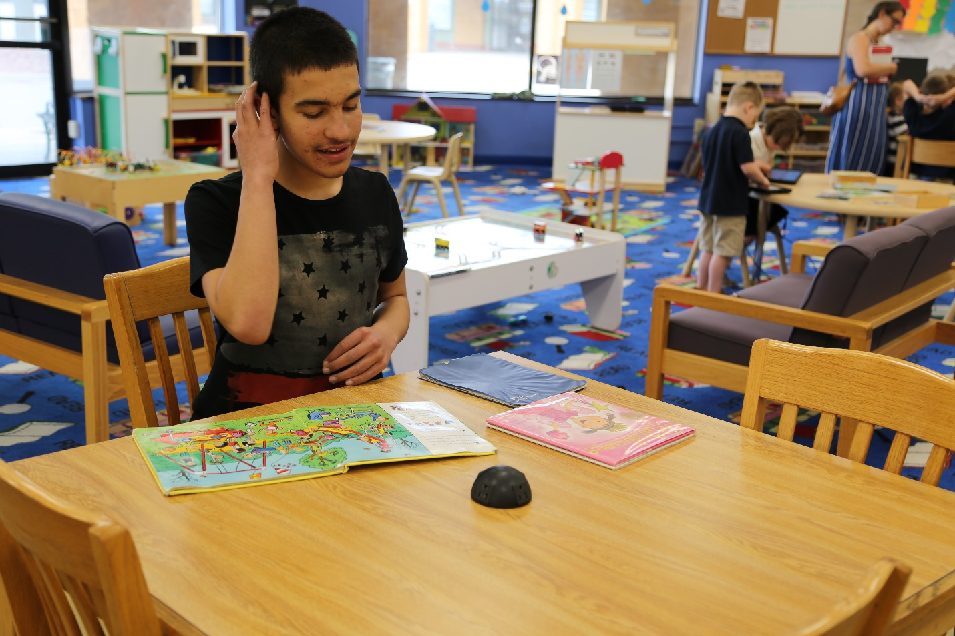
I can go to the bathroom. There are two bathrooms.
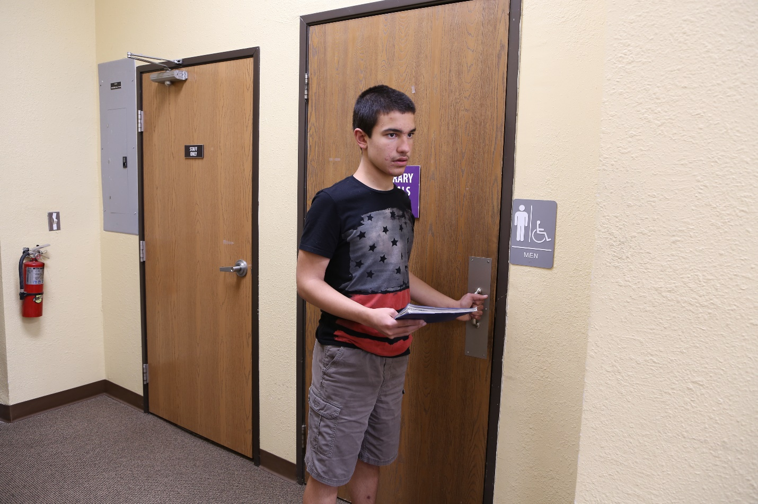
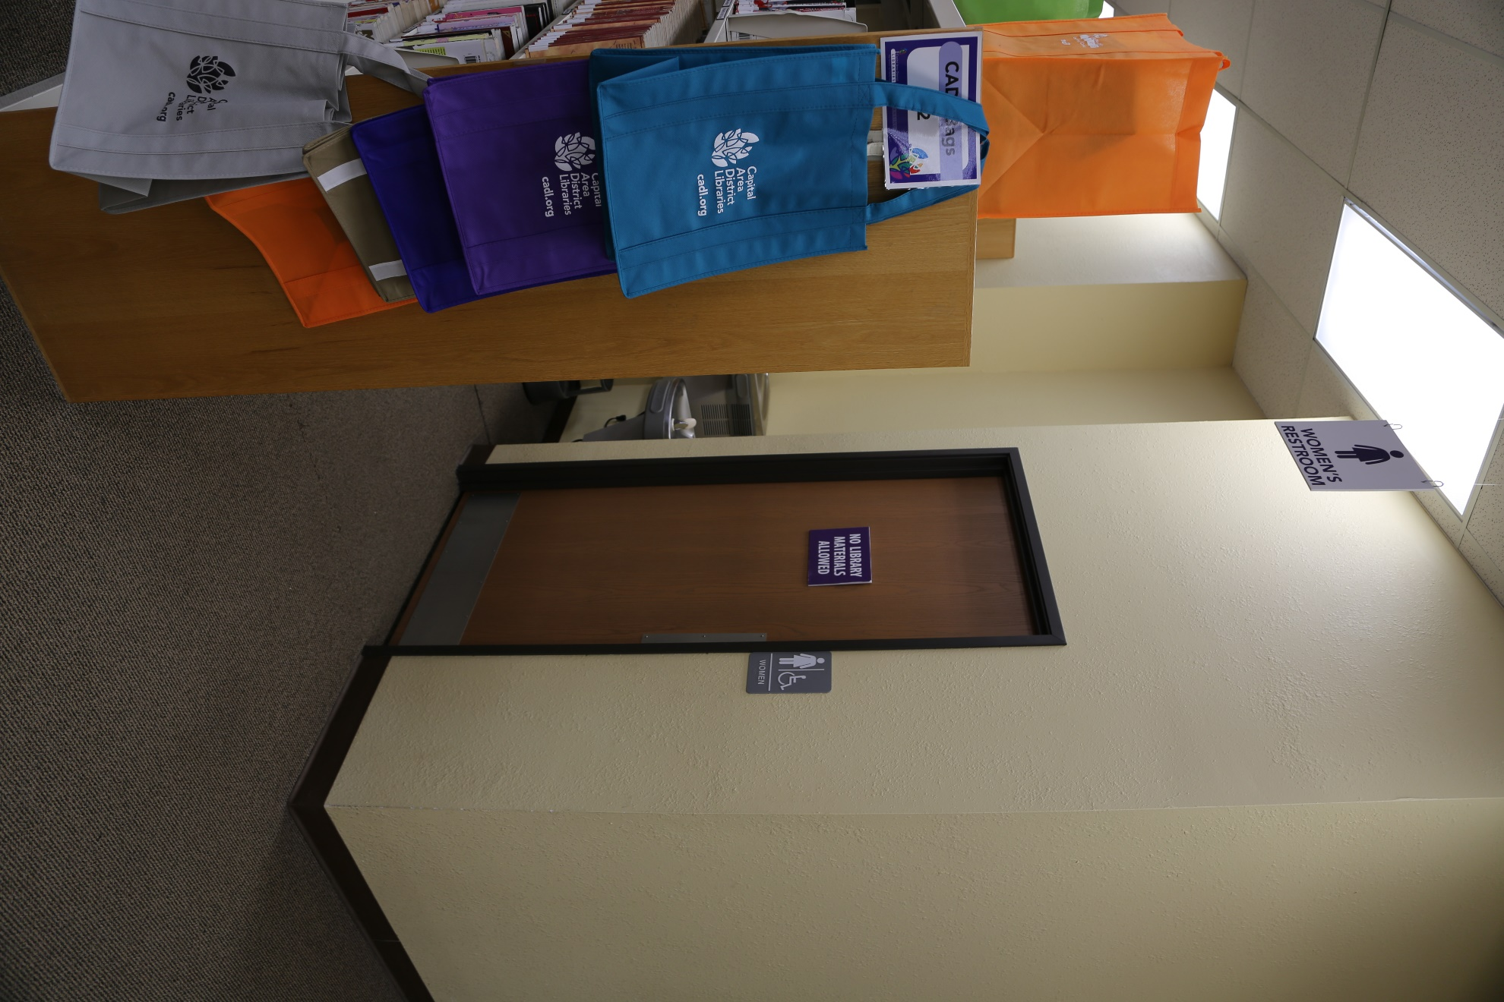
If I need a drink of water, I can use the drinking fountain.
There are places I can play in the library.
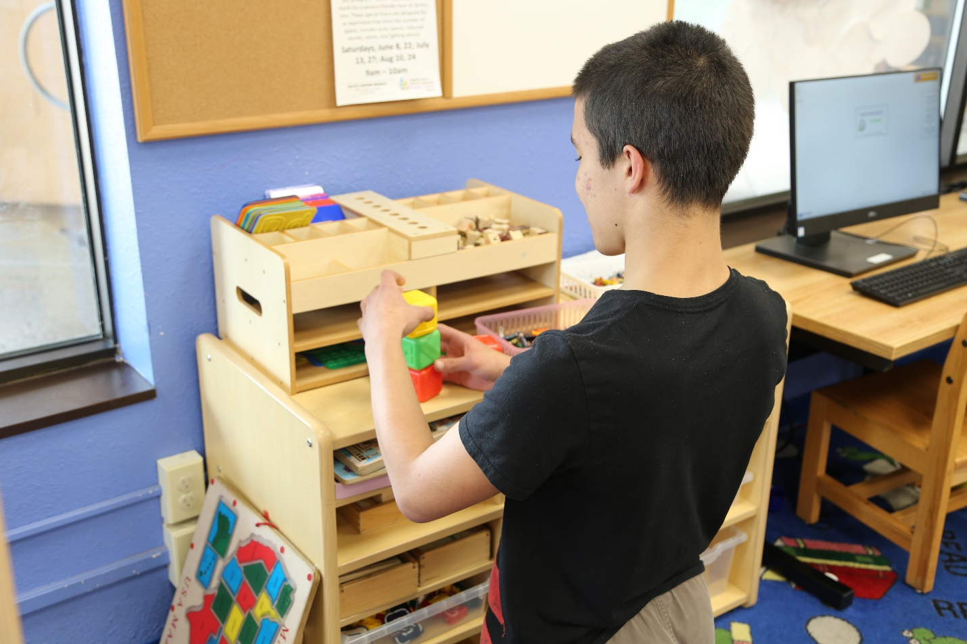
If other kids are playing I can share and take turns.
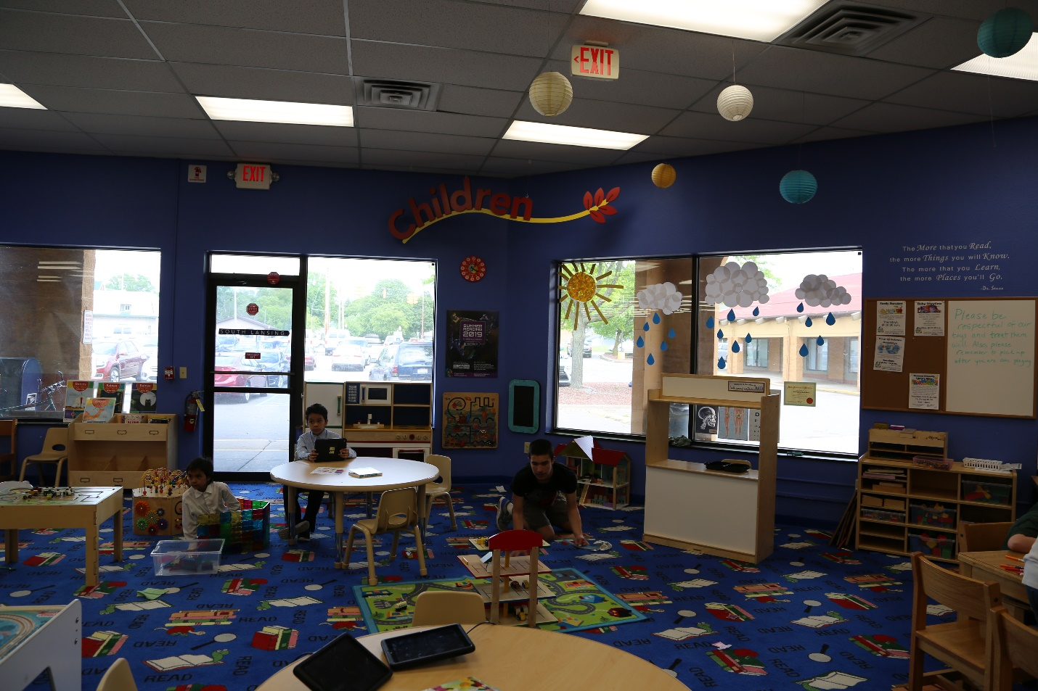
If I’m feeling overwhelmed, I can check out a sensory toolkit from the Info Desk
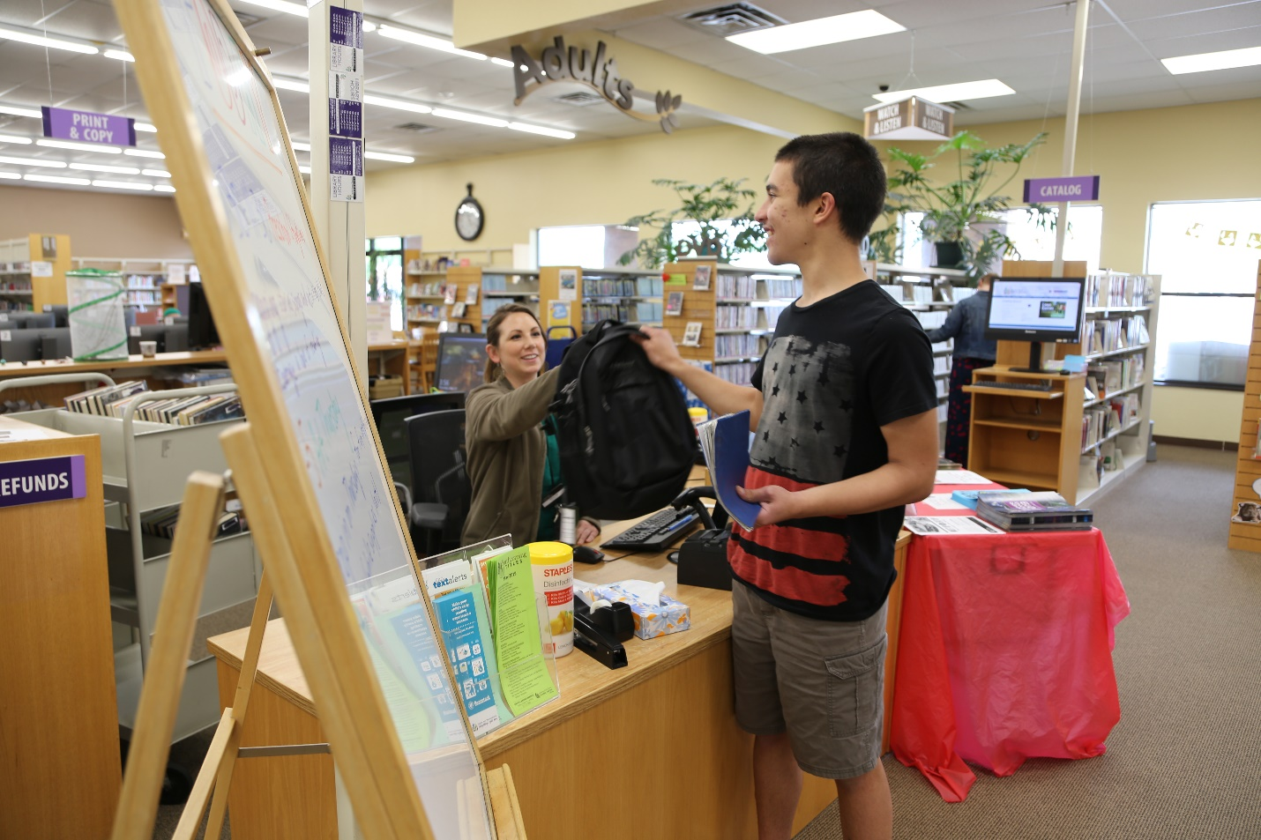
If I need help finding something, I can ask a librarian at the Info Desk.
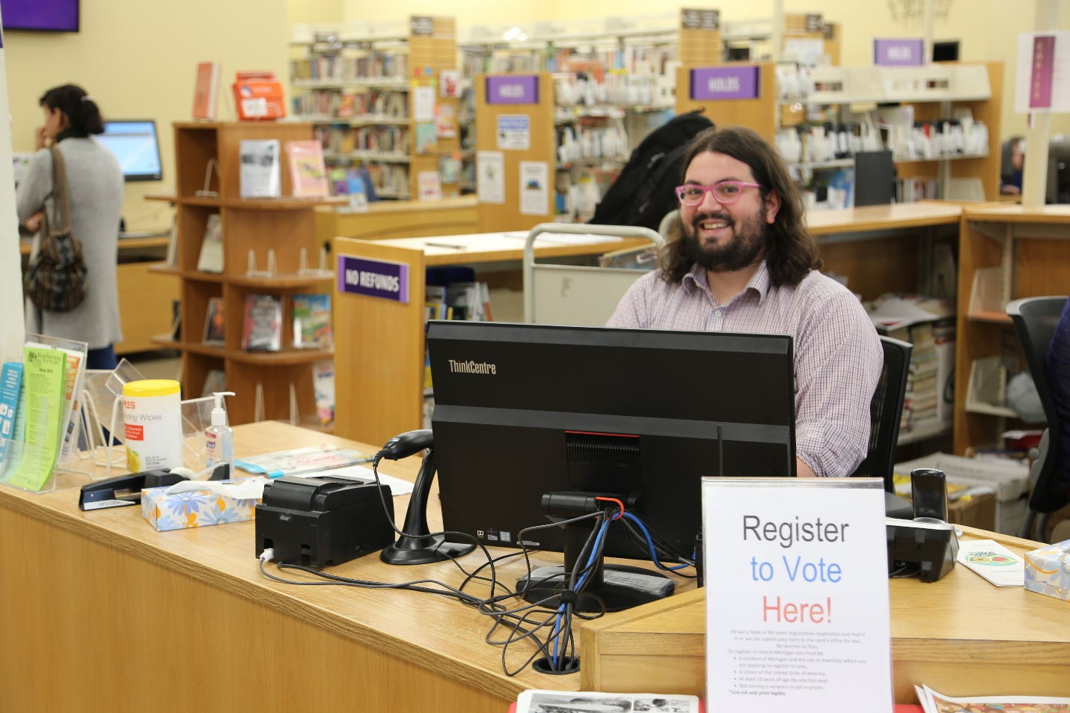
Librarians like to help people find things in the library.
When it is time to leave, I will decide if I want to borrow something and take it home with me.
I will take what I want to borrow at the checkout desk.
I will wait my turn. I will give the person at the Checkout Desk my library card.
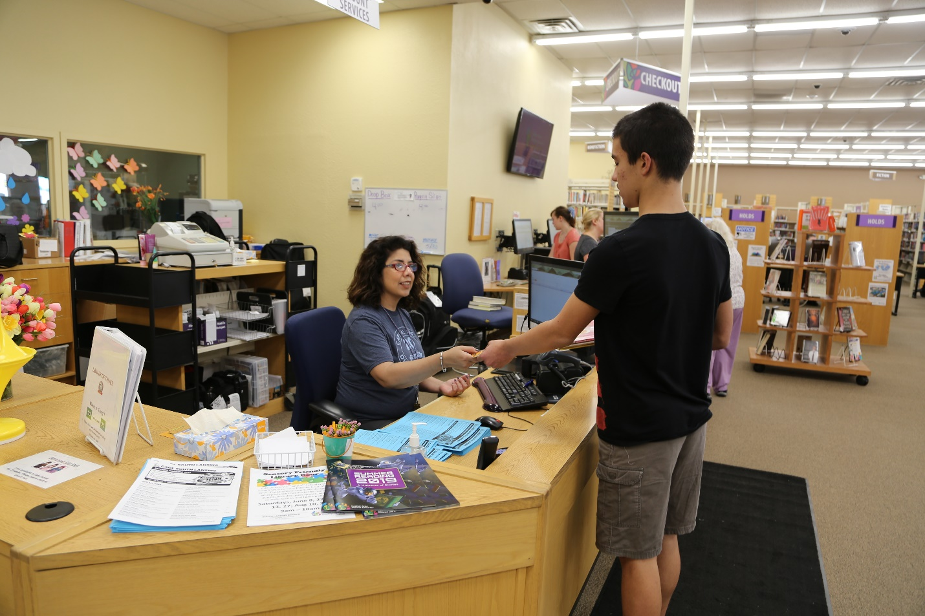
Or I can use the Self Check Stations.
If someone takes something out of the library, there will be an alarm noise to remind them to come back to the Checkout Desk and check it out.
When I finish my visit to the South Lansing Library, I will leave the library. I can come back to the library another day.
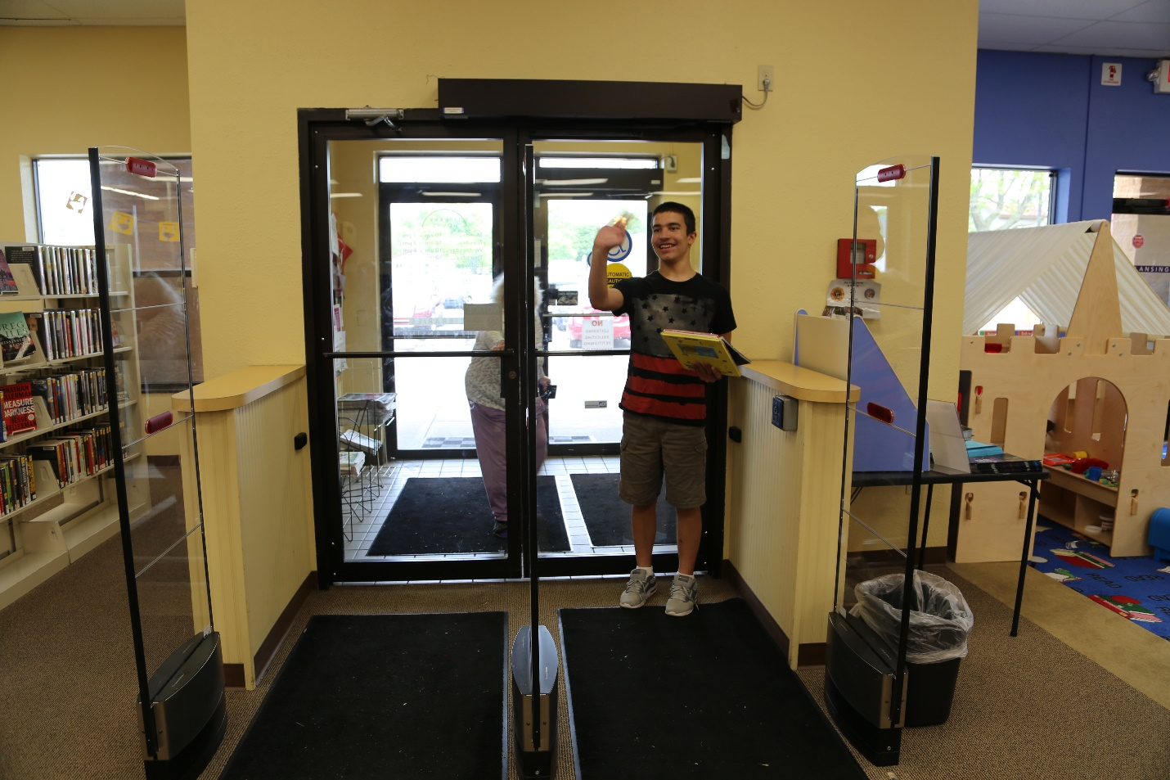
Goodbye!

